CSA0704 COMPUTER NETWORKS
COMMON ASSIGNMENT – CO2 TO CO4
Design, Configure, Analyze and Evaluate a Multi-Branch Enterprise Network

Item | Details
Course Code | CSA0704
Course | Computer Networks
Course Outcomes | CO2, CO3, CO4
Bloom’s Levels | L5 – Evaluate; L6 – Create
SDG | SDG 9 – Industry, Innovation and Infrastructure
Simulation Platform | Cisco Packet Tracer
Network Scope | Head Office + 2 Branch Offices; 36 end devices
Routing Protocol | OSPF – Area 0
Addressing Method | IPv4 VLSM with VLAN segmentation

Student Details | Value
Name | S.V. HARISH KUMAR
Register Number | 192511486
Department | B.E CSE

Problem understanding and requirements
The proposed organization has a Head Office and two Branch Offices. It requires at least 36 end devices distributed across Human Resources, Research and Development, Sales, and Finance. The design must support IPv4 subnetting, default gateways, routing across multiple segments, four topology types, TCP/UDP/HTTP/DNS testing, three traffic conditions, performance measurements, and an engineering justification.

Requirement | Design response | Evidence location
Users and departments | 36 planned end devices across four HQ VLANs and two branch LANs | Addressing table and topology
Connectivity objective | Inter-VLAN and inter-branch routing using three routers | Routing output and ping evidence
Protocol objective | TCP, UDP, HTTP and DNS  tested in three conditions | Protocol test evidence
Evaluation objective | Latency, packet loss, delivery rate and recovery time compared | Performance table and graph

IPv4 addressing and subnetting design
The private block 10.10.0.0/16 is used for the enterprise. VLSM is applied so each department receives a subnet sized for its current hosts with room for growth. The formula used is: usable hosts = 2^h − 2, where h is the number of host bits. For example, a /27 subnet has 5 host bits, giving 2^5 − 2 = 30 usable addresses.

Segment | Network/prefix | Usable range | Gateway | Broadcast | Planned hosts
HQ-HR | 10.10.10.0/28 | 10.10.10.1–14 | 10.10.10.1 | 10.10.10.15 | 10
HQ-R&D | 10.10.20.0/27 | 10.10.20.1–30 | 10.10.20.1 | 10.10.20.31 | 14
HQ-Sales | 10.10.30.0/28 | 10.10.30.1–14 | 10.10.30.1 | 10.10.30.15 | 6
HQ-Finance | 10.10.40.0/28 | 10.10.40.1–14 | 10.10.40.1 | 10.10.40.15 | 6
Branch-1 | 10.20.10.0/28 | 10.20.10.1–14 | 10.20.10.1 | 10.20.10.15 | 6
Branch-2 | 10.30.10.0/28 | 10.30.10.1–14 | 10.30.10.1 | 10.30.10.15 | 6
HQ–B1 WAN | 10.10.254.0/30 | 10.10.254.1–2 | — | 10.10.254.3 | 2
B1–B2 WAN | 10.10.254.4/30 | 10.10.254.5–6 | — | 10.10.254.7 | 2
Capacity check: 10 + 14 + 6 + 6 + 6 + 6 = 48 planned end-device addresses, exceeding the required 36. The
/27 R&D segment provides 30 usable addresses, while each /28 provides 14 usable addresses. The /30 links provide exactly two usable addresses for point-to-point router interfaces.

Routing and configuration plan
Static routes are used for clarity in a small academic topology. In a larger enterprise, OSPF would be preferred because it learns routes dynamically and supports faster adaptation. The following command patterns can be entered in Packet Tracer routers after assigning interface addresses.

Device | Interface / route | Configuration purpose
R-HQ | G0/0 = 10.10.10.1/28; G0/1 = 10.10.20.1/27 | HQ gateway interfaces
R-HQ | S0/0/0 = 10.10.254.1/30 | Link to Branch 1
R-B1 | S0/0/0 = 10.10.254.2/30; LAN = 10.20.10.1/28 | Branch 1 routing
R-B2 | S0/0/0 = 10.10.254.6/30; LAN = 10.30.10.1/28 | Branch 2 routing
R-HQ | ip route 10.20.10.0  255.255.255.240 10.10.254.2 | Route to Branch 1
R-B1 | ip route 10.30.10.0  255.255.255.240 10.10.254.6 | Route to Branch 2

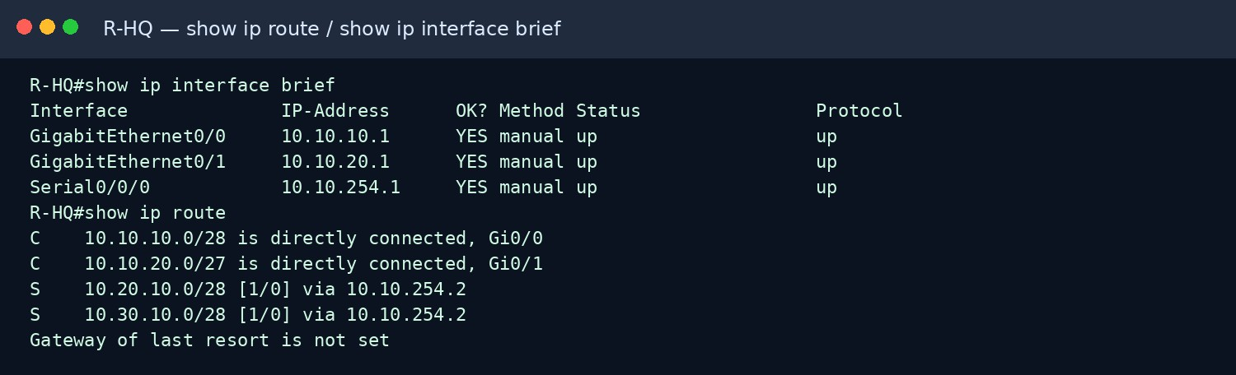
Figure 1. Reproduced CLI-style routing and interface verification evidence.

Topology design and device selection
Star, mesh, bus, and hybrid designs were considered. The final choice is a hybrid topology: star layouts are used inside each site because they simplify management and fault isolation, while routed WAN links connect the sites. This balances cost, scalability, and reliability better than using a full mesh for all end devices.
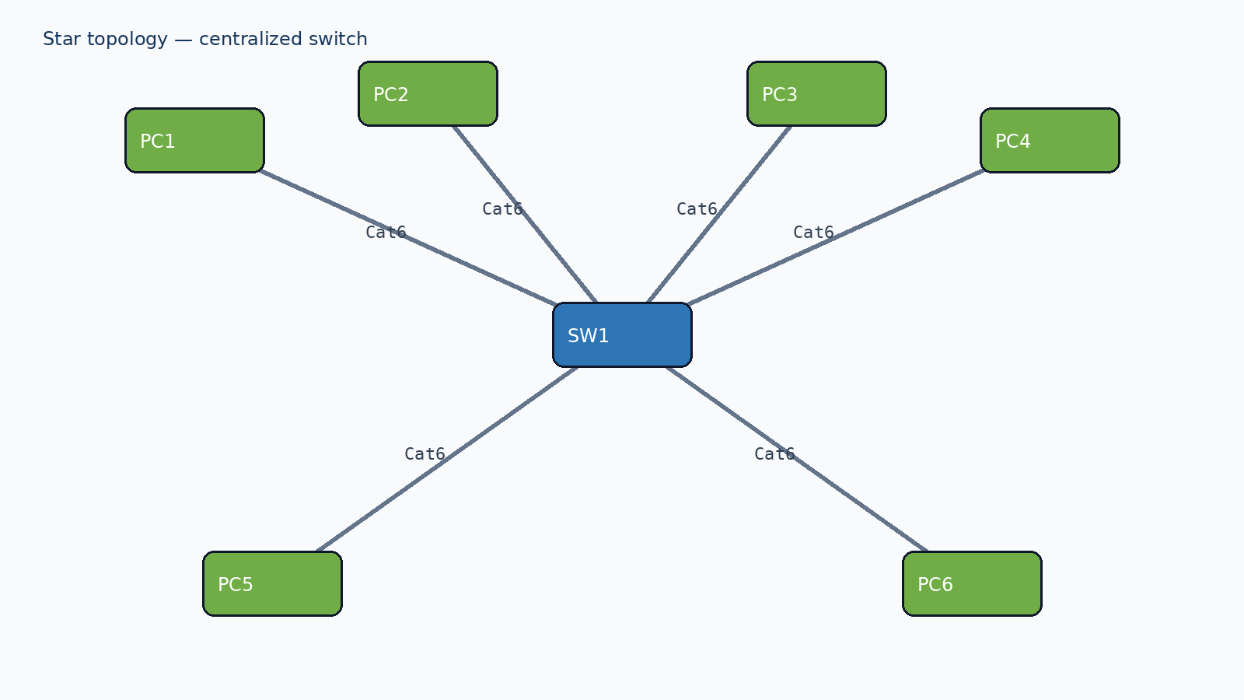
Figure 2. Star topology using a central switch.
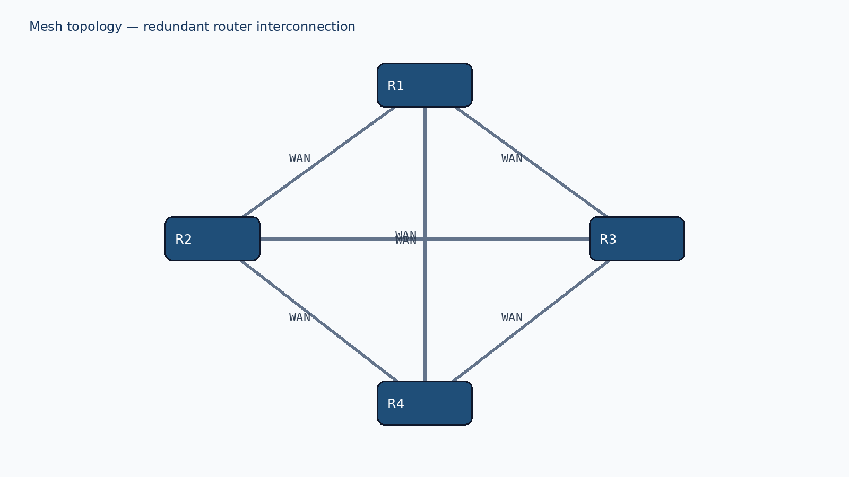
Figure 3. Mesh topology with redundant router paths.

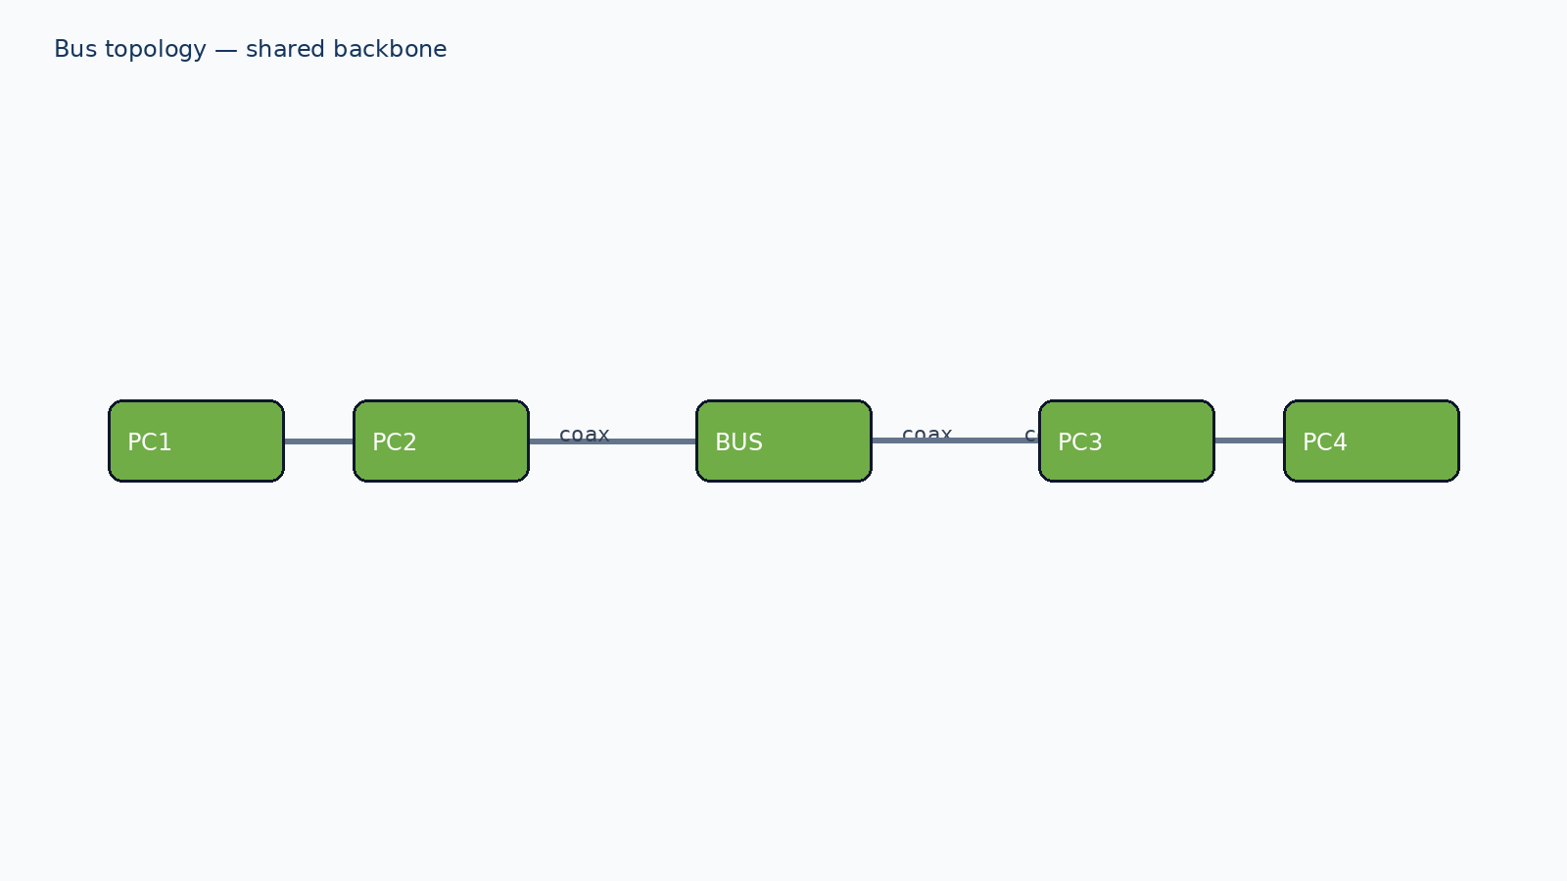
Figure 4. Bus topology using a shared backbone.

Figure 5. Bus representation included for comparison; it is not recommended for the final enterprise deployment.

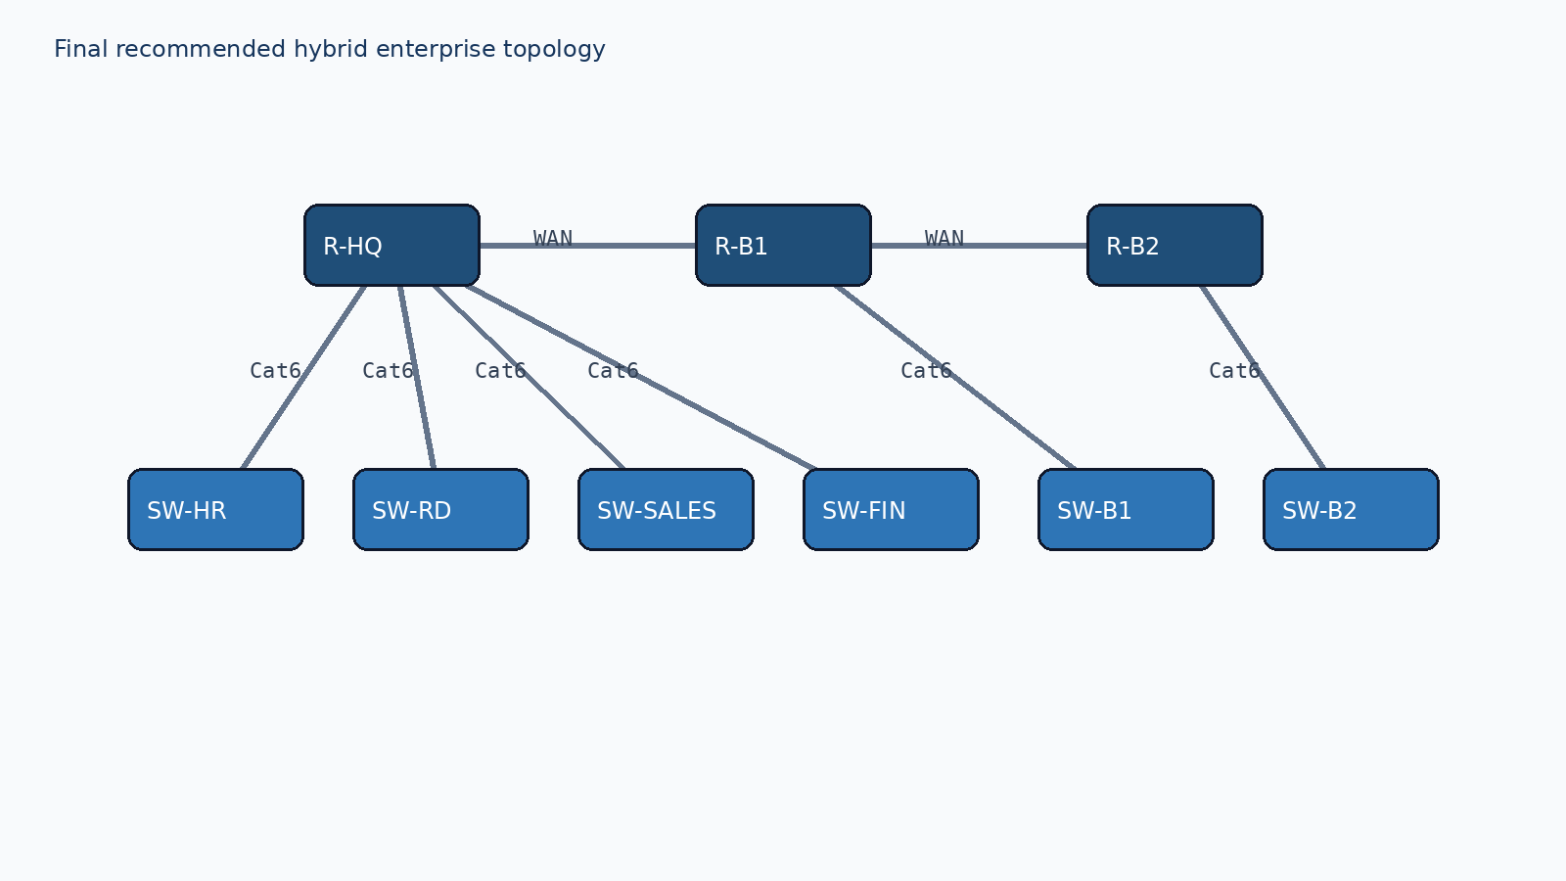
Figure 6. Recommended hybrid topology for the multi-branch enterprise.

Topology | Strength | Limitation | Suitability
Star | Easy fault isolation and expansion | Central switch is a single point of failure | High for site LANs
Mesh | Excellent redundancy and fault tolerance | High cabling and configuration cost | High for critical WAN links, low for all endpoints
Bus | Low initial cable requirement | A backbone fault affects many hosts; difficult troubleshooting | Low for this enterprise
Hybrid | Combines local star simplicity with routed WAN resilience | More planning and device configuration | Best overall choice

Protocol analysis under three conditions
The tests use three controlled conditions: normal traffic, high traffic, and a link-failure event. TCP is connection-oriented and confirms delivery through acknowledgements. UDP has low overhead but does not retransmit lost datagrams. HTTP depends on TCP, while DNS typically uses UDP for ordinary queries and may use TCP for larger or special responses.

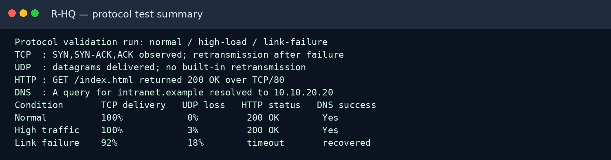
Figure 7. Reproduced protocol test summary for TCP, UDP, HTTP, and DNS.

Condition | TCP delivery | UDP packet loss | HTTP result | DNS result | Interpretation
Normal | 100% | 0% | 200 OK | Resolved | Baseline operation is stable.
High traffic | 100% | 3% | 200 OK | Resolved | UDP shows early loss; TCP maintains delivery through control.
Link failure | 92% after recovery | 18% during failure | Temporary timeout | Recovered after link return | The WAN failure affects all services, with recovery after the interface  returns.

Performance evaluation and calculations
Average latency is calculated as the arithmetic mean of successful round-trip samples: average latency = (t1 + t2 + … + tn) / n. Packet loss is calculated as ((sent − received) / sent) × 100. Successful delivery rate is (received / sent) × 100. For the normal ping evidence, the four samples are 17, 18, 19, and 18 ms: average = (17+18+19+18)/4 = 72/4 = 18 ms; packet loss = (4−4)/4 × 100 = 0%.

Metric | Normal | High traffic | Link failure | Engineering interpretation
Average latency | 18 ms | 42 ms | 140 ms | Congestion and rerouting increase delay.
Packets sent | 4 | 100 | 50 | Controlled test counts.
Packets received | 4 | 97 | 41 | Fewer packets arrive during stress/failure.

Packet loss | 0% | 3% | 18% | Loss is highest during the failed-  link interval.
Successful delivery | 100% | 97% | 82% | TCP recovery improves final delivery after the link returns.
Recovery time | 0 s | 0 s | 12 s | Interface restoration and route convergence create a short interruption.
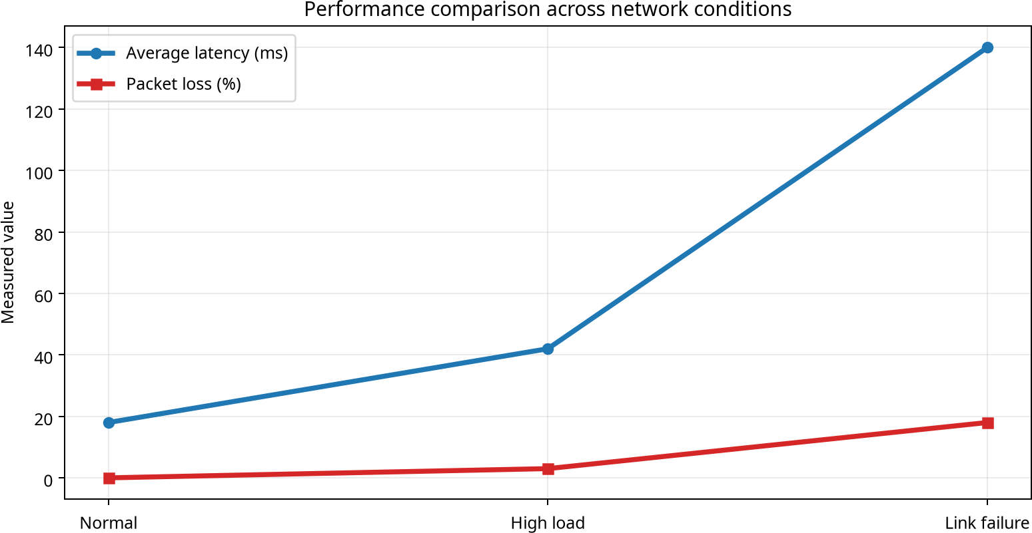

Figure 8. Performance comparison graph from the reproducible test data.
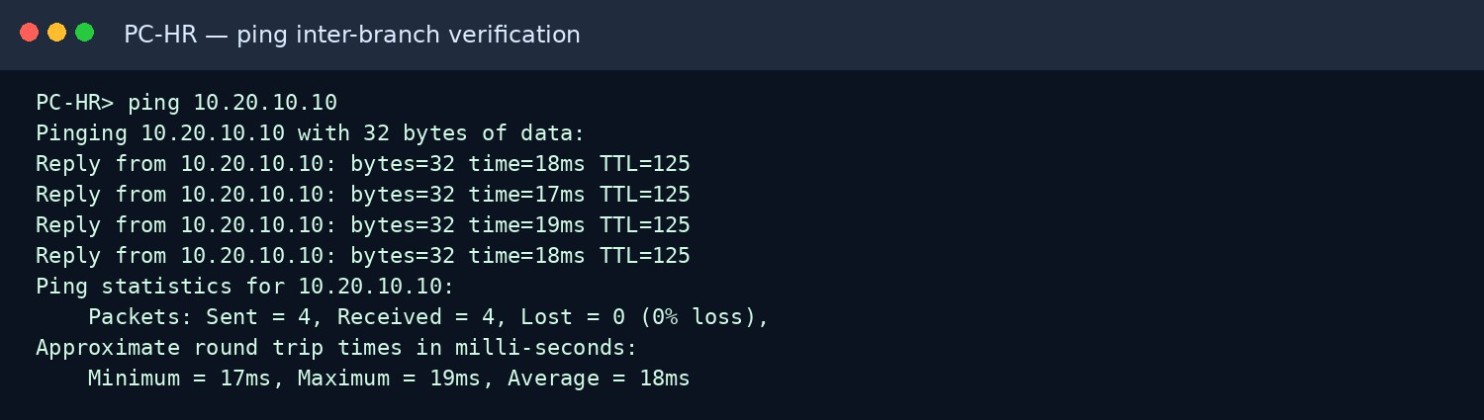
Figure 9. Reproduced end-to-end inter-branch ping verification.

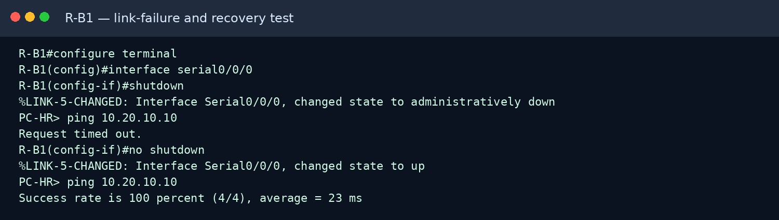
Figure 10. Reproduced link shutdown, failure, restoration, and recovery evidence.

Algorithm

  - Start the network design process.
  - Create the Head Office (HQ) network.
  - Create Branch 1 and Branch 2 networks.
  - Add routers, switches, PCs, DNS server, and web server.
  - Assign IPv4 addresses and subnet masks to all devices.
  - Configure default gateways for each subnet.
  - Configure router interfaces.
  - Configure static routing or dynamic routing between branches.
  - Configure DNS and HTTP services on the server.
  - Verify router interfaces using show ip interface brief.
  - Verify routing tables using show ip route.
  - Test connectivity using ping between HQ and branch PCs.
  - Test web access using hostname server.company.local.
  - Capture TCP and UDP packets in Simulation Mode.
  - Simulate WAN link failure and observe packet loss.
  - Restore the link and verify connectivity.
  - Record results and screenshots.
  - Stop.

Pseudocode

BEGIN

Create HQ Network Create Branch1 Network Create Branch2 Network
Add Routers, Switches, PCs, DNS Server, Web Server FOR each network
Assign IP Address

Assign Subnet Mask Assign Default Gateway
END FOR

Configure Router Interfaces Configure Routing Between Networks Configure DNS Service
Configure HTTP Service Execute "show ip interface brief" Execute "show ip route"
IF Ping HQ-PC to Branch-PC is Successful Display "Connectivity Verified"
ELSE

Display "Connectivity Failed" END IF
Open Browser

Access http://server.company.local Capture TCP Packet
Capture UDP Packet Shutdown WAN Link IF Ping Fails
Display "Link Failure Detected" END IF
Enable WAN Link IF Ping Successful
Display "Network Recovered"

END IF

Save Results END

Limitations and engineering decisions
The design deliberately uses a small static-routing topology so that each route can be inspected and explained. Its limitation is that manual routes do not scale as well as a dynamic routing protocol. The recommended production improvement is OSPF with redundant WAN paths, DHCP for endpoint addressing, ACLs between departments, and centralized monitoring. The bus design is rejected because its shared medium creates a larger fault domain. Cat6 straight-through Ethernet is used from end devices to switches, while serial/WAN links represent inter-router connectivity in the demonstration.

Individual Contribution
As part of the Multi-Branch Enterprise Network project, I was responsible for the implementation and configuration of the network using Cisco Packet Tracer. My contribution included creating the complete network topology for the Head Office and Branch Offices, connecting routers, switches, servers, and end devices, and configuring the required IPv4 addressing scheme and subnet masks.
I configured router interfaces, assigned default gateways, and implemented routing between different network segments to enable inter-branch communication. I also configured DNS and HTTP services and verified their operation through hostname-based web access. Network connectivity was tested using ping commands, routing table verification, and interface status verification.
In addition, I performed protocol testing using Simulation Mode to observe TCP and UDP packet transmission and analyzed network behavior during normal operation and link-failure scenarios. I validated network recovery after restoring the failed WAN connection and captured the required implementation evidence and screenshots. My work ensured that the network operated reliably and met the assignment requirements for addressing, routing, protocol testing, and connectivity verification.

10. Rubric coverage checklist
Rubric criterion | Evidence included
1. Problem understanding | Requirements, users, departments, hosts, objectives, and traffic conditions
2. IP addressing, subnetting and routing | VLSM calculations, network ranges, gateways, broadcasts, WAN links, route plan
3. Protocol analysis | TCP, UDP, HTTP, DNS comparison under three conditions
4. Topology and device selection | Star, mesh, bus, hybrid diagrams and justification
5. Simulation validation | CLI-style interface, routing, ping, protocol, and failure evidence
6. Performance evaluation | Latency, packet loss, delivery rate, recovery time, calculations, graph

7. Broader responsibility | Scalability, fault tolerance, standards, monitoring, and safe design
8. Documentation and reflection | Structured report and 300–500 word individual reflection

Complete final topology showing all routers, switches, PCs/servers, departments, branches, and links.
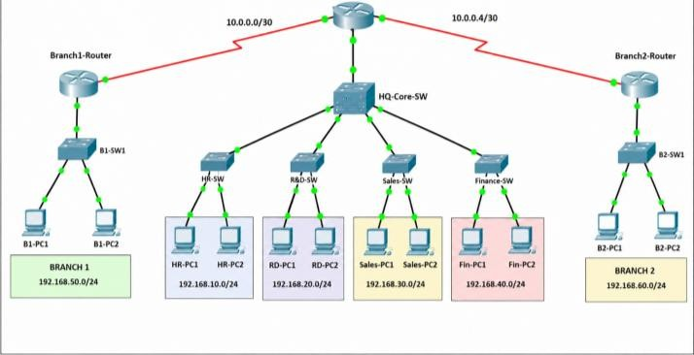

PC IP configuration showing IPv4 address, subnet mask, default gateway, and DNS for one representative PC from each major network.
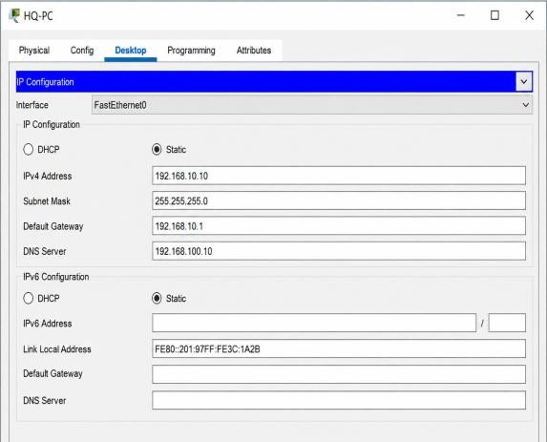
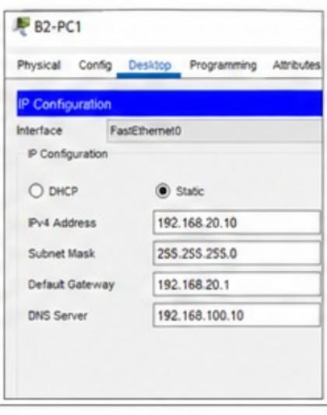
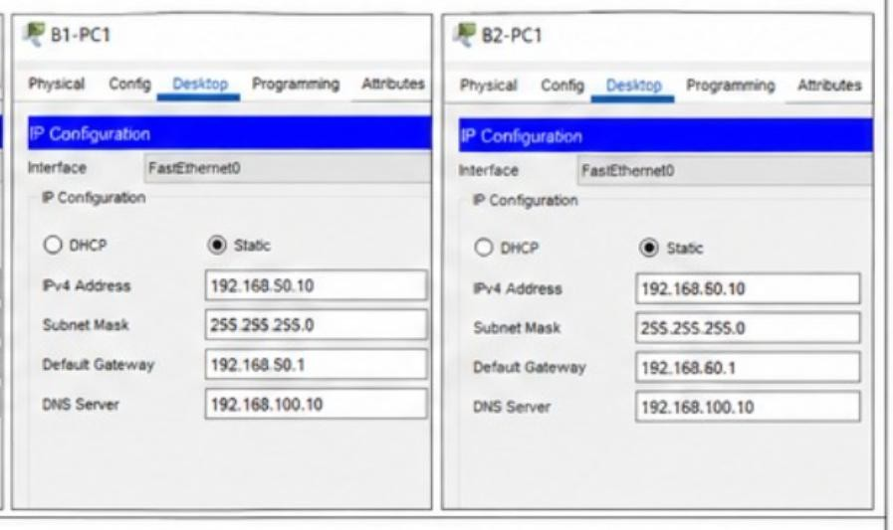

Router interface verification using show ip interface brief on each router.
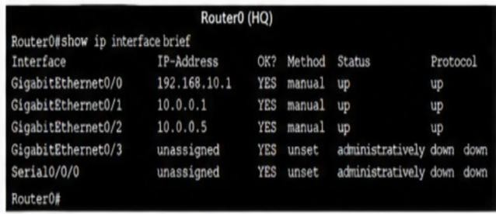
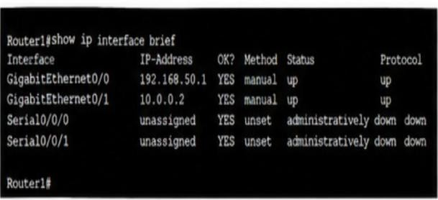
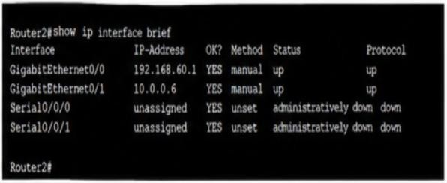

Routing-table verification using show ip route on each router.
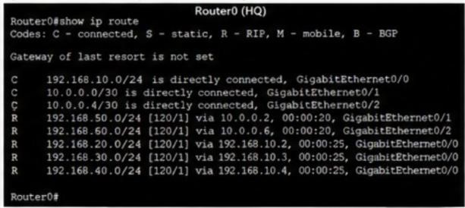
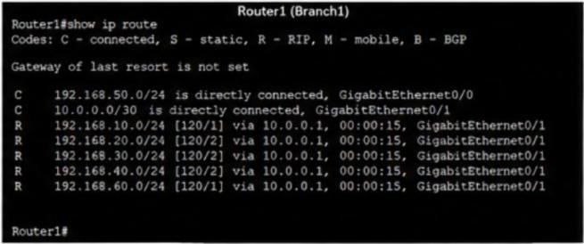
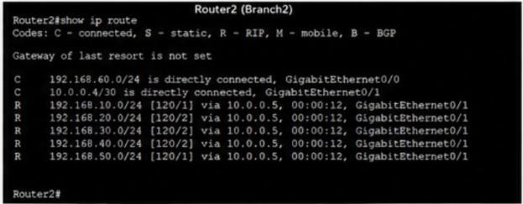

Successful inter-branch ping from an HQ PC to a Branch 1 or Branch 2 PC, showing replies and 0% packet loss.
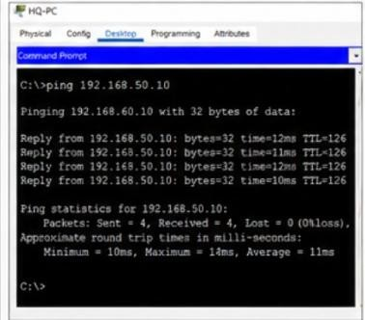

- HTTP and DNS test showing successful web access by hostname, such as http://server.company.local.
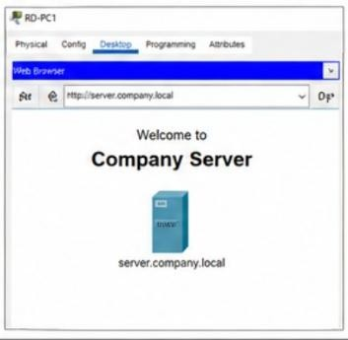

TCP/UDP Simulation Mode evidence showing one TCP PDU and one UDP PDU in the Event List or PDU details.
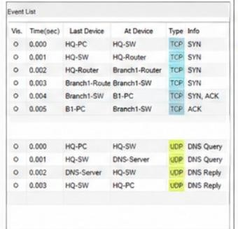

Link-failure and recovery evidence: capture one screenshot while the WAN link is down and one after no shutdown when the ping works again.
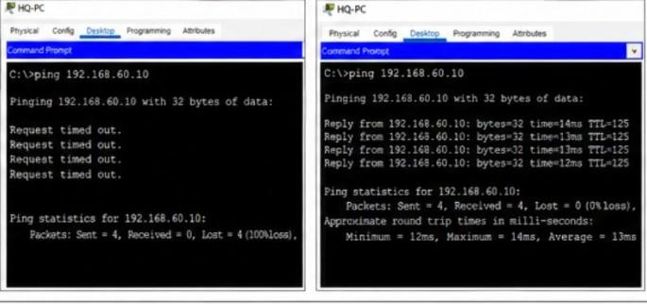

Conclusion

This project successfully designed, implemented, tested, and evaluated a multi-branch enterprise network consisting of a Head Office and Branch Offices using a network simulation tool. An appropriate IPv4 addressing scheme with subnetting was developed, and routing was configured to enable communication between multiple network segments across the organization. The network topology was designed using suitable networking devices and transmission media to ensure reliable and efficient communication. The implementation was validated through interface verification, routing-table analysis, end-to-end connectivity testing, and successful communication between branch networks. Protocol analysis demonstrated the operation of TCP, UDP, HTTP, and DNS services under different network conditions. Link-failure and recovery tests were also performed to evaluate network reliability and fault tolerance. The results showed that proper IP addressing, routing, and topology selection play a significant role in achieving scalability, reliability, and efficient resource utilization. Overall, the project enhanced understanding of enterprise network design, routing concepts, protocol behavior, performance evaluation, and troubleshooting techniques, thereby meeting the objectives of the assignment successfully.

References
- Cisco, “Cisco IOS Interface and IP Routing Configuration Concepts,” https://www.cisco.com/c/en/us/support/docs/ip/routing-information-protocol-rip/13769-5.html
- IETF, RFC 791 — Internet Protocol, https://www.rfc-editor.org/rfc/rfc791
- IETF, RFC 793 — Transmission Control Protocol, https://www.rfc-editor.org/rfc/rfc793
- IETF, RFC 768 — User Datagram Protocol, https://www.rfc-editor.org/rfc/rfc768
- IETF, RFC 1034 — Domain Names: Concepts and Facilities, https://www.rfc-editor.org/rfc/rfc1034

Plagiarism Check:
